Supporters

The Trenton Museum Society would like to thank the following

organizations for their support of the Trenton City Museum.

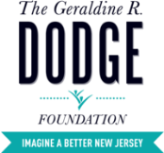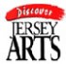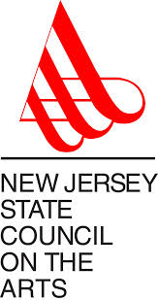

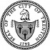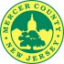

Ellarslie Mansion is owned and maintained by the City of Trenton.
Funding support for Trenton City Museum operations is provided by members and patrons of the Trenton Museum Society and, in part, by the Geraldine R. Dodge Foundation, the I Am Trenton Foundation, the New Jersey Manufacturers Insurance Group, the New Jersey Historical Commission, the Mercer County Cultural and Heritage Commission through funding from the Mercer County Board of Chosen Freeholders, and the New Jersey State Council on the Arts/Department of State, a partner agency of the National Endowment of the Arts. The Trenton Museum Society received an operating support grant from the NJ Historical Commission, a division of the Department of State.

