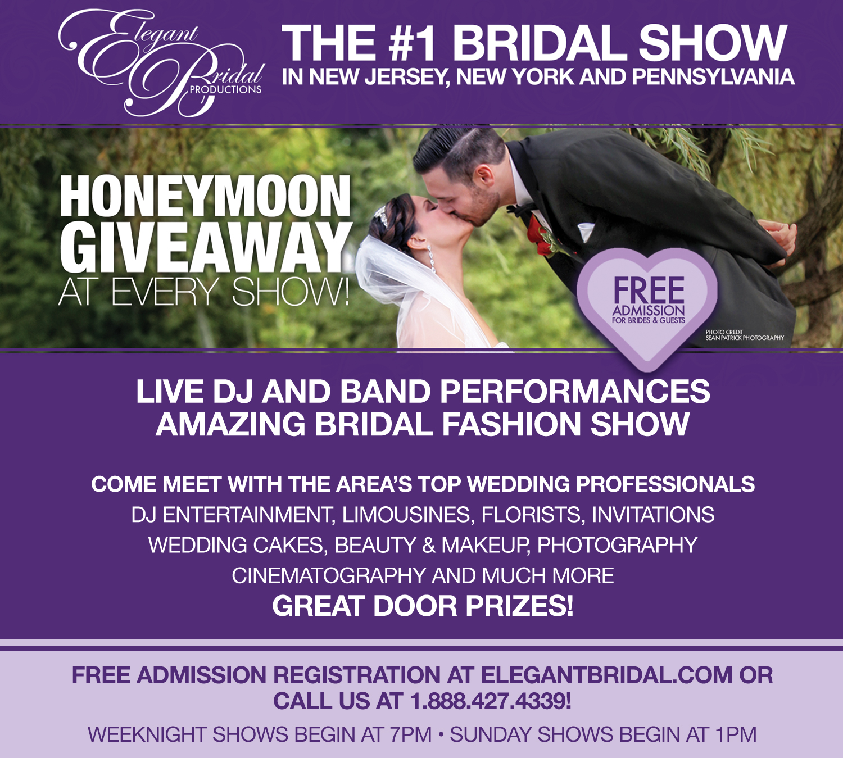
OCTOBER 2nd 2016 1:00 pm
THE TRENTON MUSEUM AT ELLARSLIE MANSION
CADWALADER PARK, 299 PARKSIDE AVENUE
TRENTON, NJ 08606
FREE REGISTRATION AT ELEGANTBRIDAL.COM
VIEW VIDEOS FROM PREVIOUS SHOWS AT ELEGANTBRIDAL.COM/BLOG
FACEBOOK | TWITTER | INSTAGRAM

