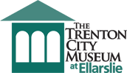

The Trenton Museum Society of the Trenton City Museum

Strategic Plan 2015-2018

Approved by the Trustees of the Trenton Museum Society
September 16, 2015

President Trenton Museum Society, Jean Bickal

Director, Donna Carcaci Rhodes

Table of Contents

Director’s Summary……………………………………….……………….…...1

Strategic Planning Team....……………………………………………...….…..1

History of the Trenton City Museum…………………………………..……….2

Statements of Mission and Vision…………………………………..…………. 3

Current Environment……………………………………………………………4

Strategic Planning Category Descriptions............................................……..........5

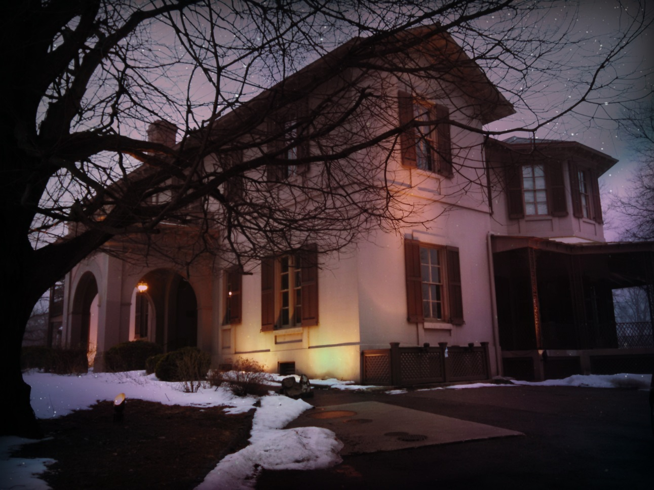

Ellarslie Mansion, Cadwalader Park
Trenton New Jersey

Director’s Summary

The development of the Strategic Plan 2015-2018 for application by the Trenton Museum Society (TMS) has been a thirteen-month guided process of research and discussion. The committee comprising the Strategic Plan has employed participatory and constructive exchanges for the growth and future development of programming and exhibitions in the Trenton City Museum.

This Strategic Plan is designed to take unfulfilled or incomplete ambitions and interests, expressed by the board, the employees and museum visitors and develop a functioning structure in which goals can be realistically and successfully achieved.

Expanded success and adherence to our mission statement and vision statement guided our discussions. Focus areas evolved: continued and strengthened adherence to museum standards and best practices; relevance in programming and exhibitions; communication strengthening and fiscal soundness for continued growth and professional excellence.

As a first Strategic Plan for the Trenton Museum Society, many actions are expressed in focused phases.
The Strategic Plan team believes these actions are necessary to strengthen foundations for greater growth.

These discussions included the study of recent challenges the museum faces. One challenge brought a full consensus: to bring exhibitions and programming to the museum that more thoroughly reflect the population of the City and the region while remaining true to the TMS mission and vision statements.

Additional challenges include strengthening communication, both external with the City of Trenton and the region and internal to support the growth of the museum.

With the reality of funding limitations, fiscal soundness and growth is of great importance for success. This will benefit both the museum and support the City of Trenton in its own growth challenges.

I am very encouraged that this Strategic Plan team has worked purposefully with me to produce an achievable and realistic guide for success and growth over the next three years.

I wish to express many thanks to our dedicated Board of Trustees, from which this exceptional team of planners has emerged to meticulously strategize for success in a determined collaboration.

The Strategic Planning Team
Marlene Barnhart, Trenton Museum Society Trustee
David Bosted, Trenton Museum Society Trustee
Joseph Longino, Trenton Museum Society Trustee
Joan Perkes, Trenton Museum Society Trustee
Richard Willinger, Trenton Museum Society Past-President

With sincere thanks,

Donna Carcaci Rhodes
Director, Trenton Museum Society

(1)
History of the Trenton City Museum

Ellarslie, an Italianate villa, was built for Henry McCall Sr. of Philadelphia as a summer residence in 1848. The architect selected to design Ellarslie was John Notman, known for designing the first Italianate building in America in Burlington, NJ, and the first Renaissance Revival building, the Athenaeum, in Philadelphia. Notman was locally recognized for designing the 1845 expansion of the New Jersey State House and the design for the New Jersey State Hospital, which was also begun in 1848.

In February 1881, Henry McCall Jr. sold Ellarslie to George Farlee for $25,000. The building has been home to several noted Trenton families during the 40 years of private ownership.

Edmund C. Hill, a restaurateur by trade, a developer by avocation, and a member of the Common Council, was chairman of a committee and principal advocate for the idea of a city park. In September of 1888, the City of Trenton acquired the property from Farlee for $50,000 that included the surrounding 80 acres, which became the first city park - Cadwalader Park.

After purchase of the McCall estate, Mr. Hill personally went to Brookline Massachusetts to contact the father of landscape architecture, Frederick Law Olmsted, to design the park. Olmsted’s style is defined by natural rolling landscape, plantings of various species and subspecies of trees and shrubs, the consistent use of curved footpaths and roadways, and often the addition of animals in a natural habitat.

Though perhaps best known for his design of Central Park in New York City, Olmsted applied the same approach to the nearly one hundred acres of the new park, which had been expanded to 100 acres. Cadwalader Park offers a stream, a small lake and hundreds of trees, including some that are rare at this latitude. The feeder of the historic Delaware and Raritan Canal flows through the park, a perfect setting for quiet nature walks.

The City of Trenton opened the first museum here in 1889, which closed several years later. Ellarslie has also been a restaurant, ice cream parlor and zoo during its existence.

In 1971, renovations began to transform what had been a monkey house into the Trenton City Museum. The Museum opened in 1978 in Ellarslie with an exhibition from our permanent collection of Trenton cultural history. Cadwalader Park, including Ellarslie, is listed on the National Register of Historic Places.

(2)

Statements of Mission and Vision

Mission Statement: Through its exhibits, collections, and community programs, the Trenton City Museum preserves and promotes the diverse history, art, and culture of Trenton and the greater Trenton area for the benefit of Trenton residents and visitors.

Vision Statement: The Trenton City Museum is a model museum working to keep the arts, culture, and history of the community alive and relevant and, as a result, helps redefine the perception of the city of Trenton. We will attain our vision by being financially sustainable, effectively governed, diverse and collaborative.

Adopted February 2011

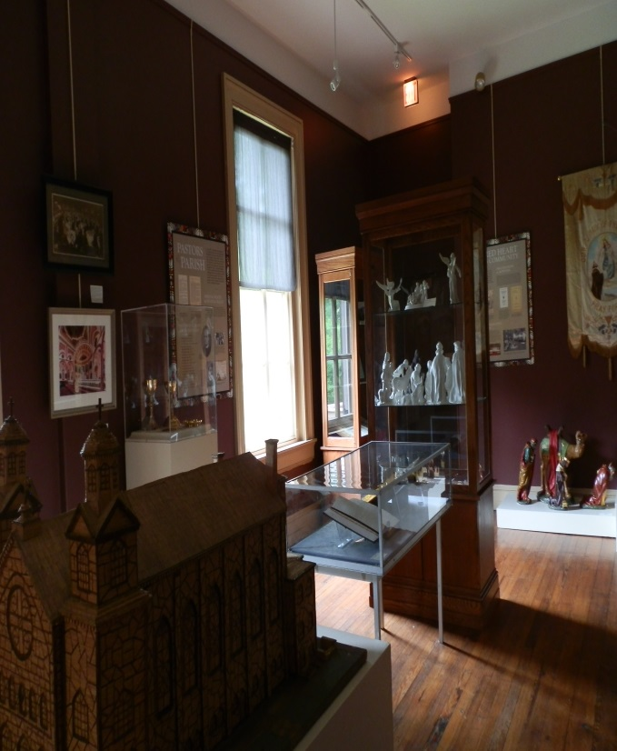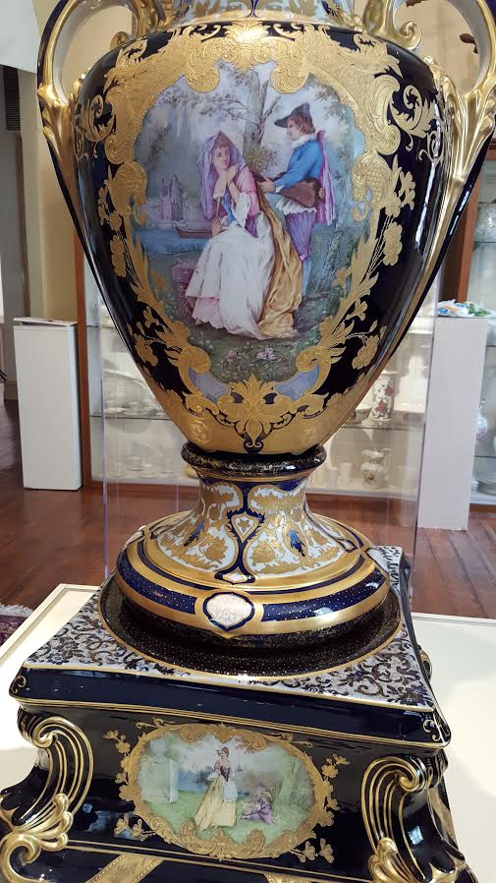

(3)
Current Environment

The Trenton Museum Society was created as a 501(c)(3) non-profit organization in 1973 to support the development and operation of the Trenton City Museum. In 2004, the Trenton Museum Society and the City of Trenton decided to formalize their relationship and executed a Management Agreement for the operation of the Museum. A copy of the 2004 Management Agreement is attached as Exhibit 1. The Management Agreement sets forth the responsibilities of the parties. The Trenton Museum Society holds the Collection in trust; the City owns the Museum building and is responsible for maintaining the building and grounds. The City also commits to employing a full-time, qualified Museum director.
Up until 2011, the Museum was operated by City employees: a full-time Director, full-time assistant, part-time secretary and part-time greeters. As owner of the building, the City provided regular maintenance, structural repairs and improvements.

The environment dramatically changed in 2011 when a financial crisis forced the City to lay off all of the museum’s staff. Up to that time, the Trenton Museum Society had operated a relatively modest organization that provided volunteers to run fundraisers, stage historical exhibits, lectures, musical performances, educational classes and special events. The Society employed a part-time Board Assistant. Without professional staff, the Museum Society was unable to apply for grants requiring a professional staff and other museums demanded the return of loaned objects.

After the loss of City support, The Board of Trustees made the decision to raise the necessary funds to keep the Museum open and to hire a museum professional as Director. The Museum Society committed itself to applying for more grants, holding additional fundraising events, and soliciting individual and corporate contributions.

This decision also required that the Museum Society to adopt best practices of professional policies and procedures, create chaired committees for contemporary art and history exhibitions, work with the City on maintenance of the building, and improve its administrative operations. These were significant and necessary challenges for a staff of 75 volunteers.

Upon hiring a Director, a committee was comprised of Trustees who have worked or currently work in, urban planning and growth, business and the museum and art industries. The Strategic Planning team has drawn not only from their professional exposure in their areas of expertise, but also from their experiences in working with and creating strategic plans for their business growth.

As a consequence of this first Strategic Plan, the Trenton Museum Society hopes to become financially secure, strengthen internal operations, increase visitation by communities of people that are not currently utilizing the museum, improve its positive working relationship with the city, continue its stewardship of the Trenton history collection, increase and strengthen collaborations with other organizations both inside and outside the city, increase educational opportunities and training, increase sponsorships of museum activities, and increase the professional operation of the museum.

Strategic Planning Category Descriptions

The Strategic Plan Categories

- Committee Responsibility
- Action
- Action/Progress
- Description of Conclusion
- Goal

- Committee Responsibility
The Trenton Museum Society supports the Trenton City Museum with a staff of three part-time employees and numerous volunteers divided into 15 committees. These committees are chaired by Trustees of the Trenton Museum Society. Committee Chairs are managing the committees for success and supervision of tasks. Committee Chairs will be implementing the Actions of the Strategic Plan if their committee is named as the responsible committee. All Committee Chairs meet with the Director for adherence to the Strategic Plan goals.

Nearly all Actions will require a team effort of more than one committee to achieve the
goals for success. Committee Chairs will need to arrange to meet to ensure the success of their combined goals.

- Action
The needed Actions are described in straightforward broad language to allow for maximum achievement of the goal, based on the ability of the committee.

- Action/Progress
This is a guide to track the time frame in achieving stated goals.

- Description of Conclusion
The specific action that needs to be taken is described in straightforward broad language to allow for maximum achievement of the committee.

- Goal
This is the anticipated time of the desired outcome over the three year projection.

We are proud to advance the path of an extraordinary association for the support and continued growth of a great museum. Together we make a great museum greater still, for generations to come.

